電通二乙微處理器實驗 實驗結報

實驗名稱 | Lab03-類比輸入
組別 |  | 組員 | 吳東燁

- 實驗目的
*使用USB-Serial作為輸入輸出
*讀取類比輸入之數值
1.量測 0/0.5/1/1.5/2/2.5之電壓值
2.量測可變電阻之數值
3.量測光敏電阻之數值
- 實驗步驟
- 輸入Hello World訊息給PC，並由PC傳送指令至Arduino，`1’亮 `0’暗
- 量測 0/0.5/1/1.5/2/2.5之電壓值並記錄
- 量測可變電阻之數值
- 量測光敏電阻之數值
- 程式碼
1.
const byte ledPin = 7;

void setup() {
Serial.begin(9600);
Serial.print("Hello,World\n");
pinMode(ledPin, OUTPUT);
}
void loop() {
if (Serial.available()) {
char val = Serial.read();
if (val == '1') {
digitalWrite(ledPin, HIGH);
Serial.print("LED ON\n");
}
else if (val == '0') {
digitalWrite(ledPin, LOW);
Serial.print("LED OFF\n");
}
}
}
2.
float Analogin = 0, Vin = 0;
int i;
void setup() {
Serial.begin(9600);
}
void loop() {
for (i = 0; i <= 5; i++)
Analogin = 0.7 * Analogin + 0.3 * analogRead(A0);
Vin = Analogin * 2.5 / 4095;
Serial.println(Vin);
delay(100);
}
3.
float r2=1017300;
void setup() {
// put your setup code here, to run once:
Serial.begin(9600);
}
void loop() {
// put your main code here, to run repeatedly:
float Analogin,sensorValue,sensorVoltage,ResisterValue;
float R1;

for (int i=0;i<=5;i++)
{
sensorValue = 0.7* sensorValue + 0.3* analogRead(A0);
Serial.print(i);
Serial.print(":");
Serial.println(analogRead(A0));
}

sensorVoltage = sensorValue *2.5 / 4095;
R1 = sensorVoltage * r2 / 2.5;

Serial.println(sensorVoltage);
Serial.println(sensorValue);
Serial.println(R1);
delay(1000);
}
4.
float r2=1017300;
void setup() {
// put your setup code here, to run once:
Serial.begin(9600);
}
void loop() {
// put your main code here, to run repeatedly:
float Analogin,sensorValue,sensorVoltage,ResisterValue;
float R1;

for (int i=0;i<=5;i++)
{
sensorValue = 0.7* sensorValue + 0.3* analogRead(A0);
Serial.print(i);
Serial.print(":");
Serial.println(analogRead(A0));
}

sensorVoltage = sensorValue *2.5 / 4095;
R1 = sensorVoltage * r2 / 2.5;

Serial.println(sensorVoltage);
Serial.println(sensorValue);
Serial.println(R1);
delay(1000);
}

- 實驗結果及分析
實驗步驟1
PC輸入 | SerialMonitor 輸出 | LED狀態
0 | 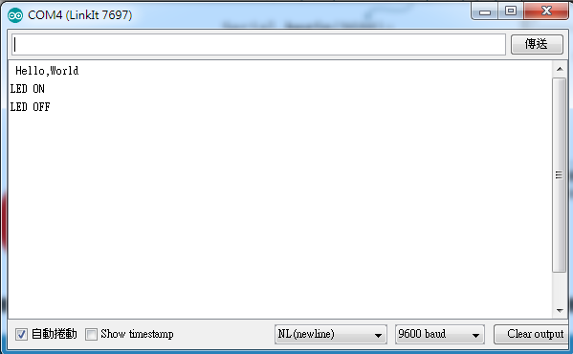 | 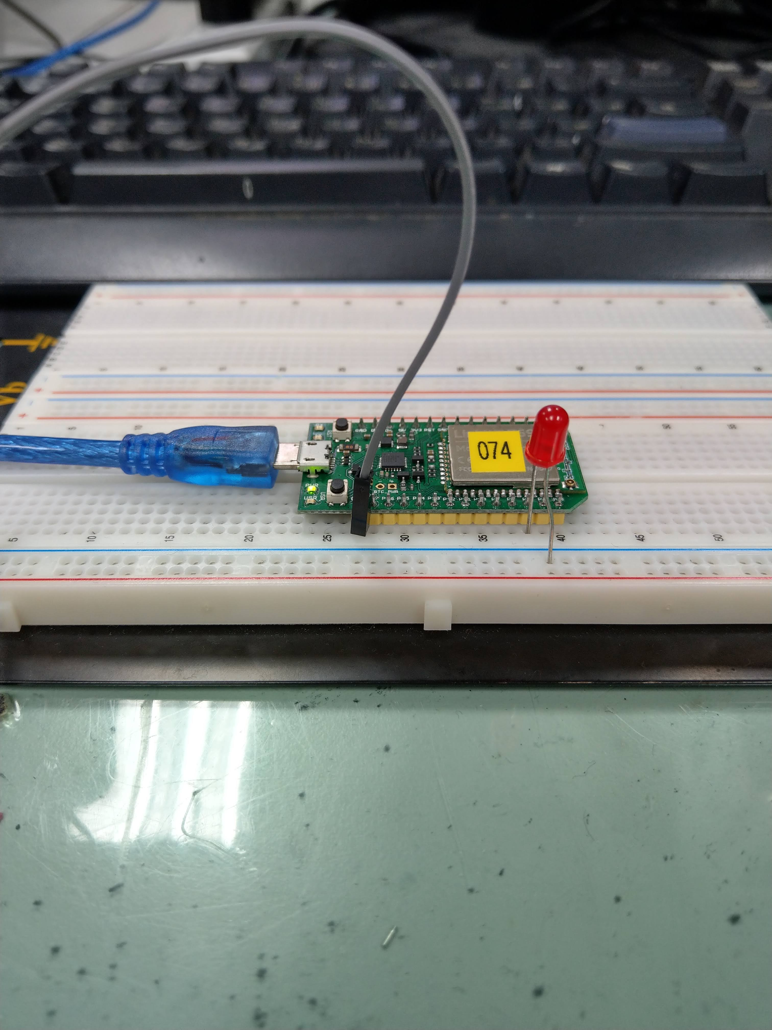
1 | 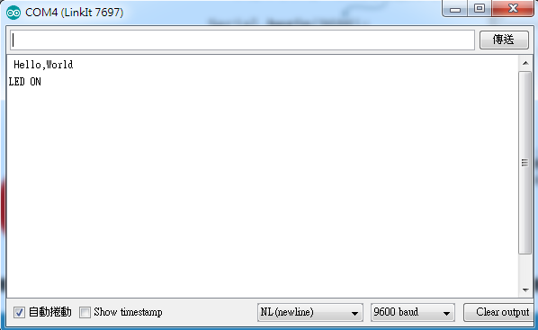 | 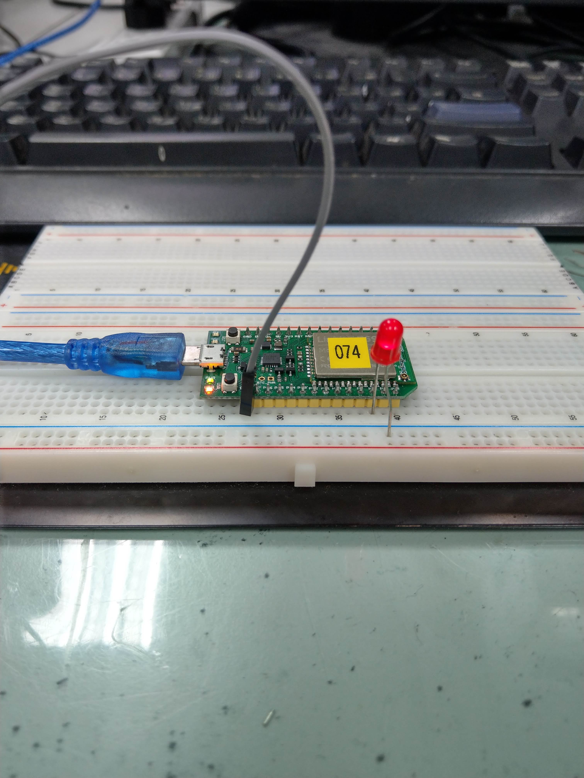

實驗步驟2
實際電壓 | AnalogRead 讀值 | 推測電壓 (V)
0 | 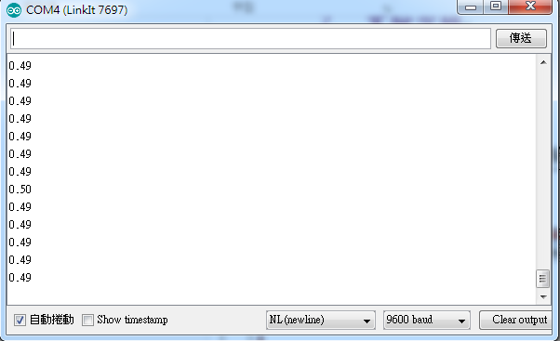 | 0
0.5 |  | 0.5
1 | 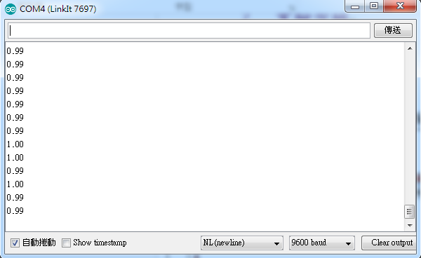 | 1
1.5 | 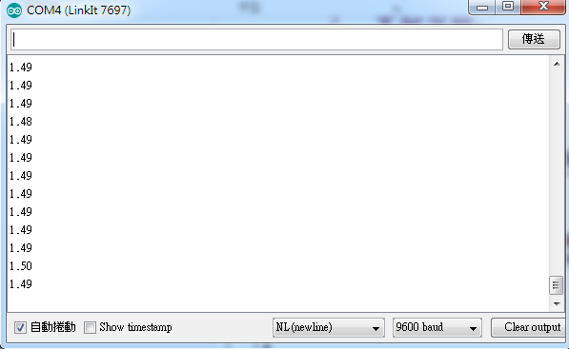 | 1.5
2 | 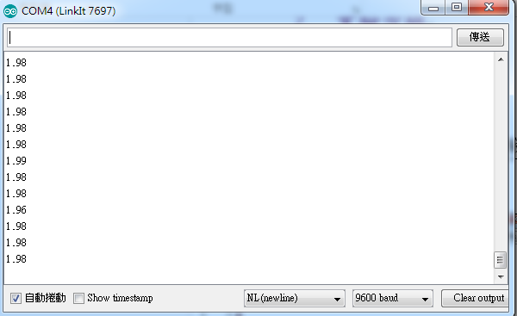 | 2
2.5 | 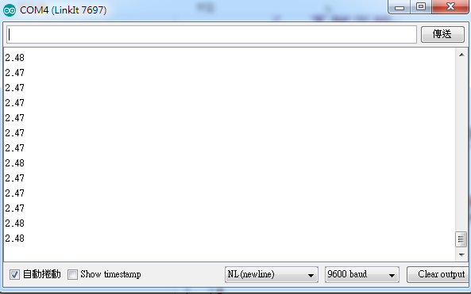 | 2.5
實驗步驟3
可變電阻量測值(Ω) | AnalogRead讀值 | 推測電壓(V) |  | 推測電阻值(Ω) | SerialMonitor輸出
10169 | 375 | 0.2V | 887.89 |  | 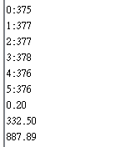
10169 | 4093 | 2.2 | 9643.8 |  | 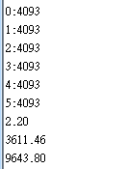
1001356 | 4 | 0.0 | 1137.06 |  | 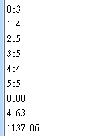
1001356 | 4093 | 2.2 | 886770.63 |  | 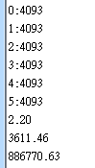
1017300 | 150 | 0.09 | 34775.53 |  | 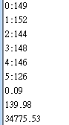
1017300 | 55 | 0.03 | 11811.97 |  | 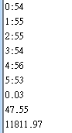
實驗步驟4
AnalogRead讀值 | 推測電壓(V) | 推測電阻值(Ω) | SerialMonitor輸出
545 | 0.28 | 1515.79 | 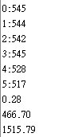
1560 | 0.80 | 4275.4 | 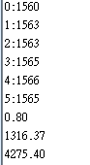
3567 | 1.93 | 10285.74 | 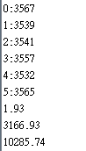

- 心得討論
這周的實驗，有點稍稍增加難度，且量測的數值變多，也常常搞得很混亂。
- 修正程式碼
float r2=1017300;
void setup() {
// put your setup code here, to run once:
Serial.begin(9600);
}
void loop() {
// put your main code here, to run repeatedly:
float Analogin,sensorValue,sensorVoltage,ResisterValue;
float R1;

for (int i=0;i<=5;i++)
{
sensorValue = 0.7* sensorValue + 0.3* analogRead(A0);
Serial.print(i);
Serial.print(":");
Serial.println(analogRead(A0));
}

sensorVoltage = sensorValue *2.5 / 4095;
R1 = sensorVoltage * r2 / 2.5;

Serial.println(sensorVoltage);
Serial.println(sensorValue);
Serial.println(R1);
delay(1000);
}

